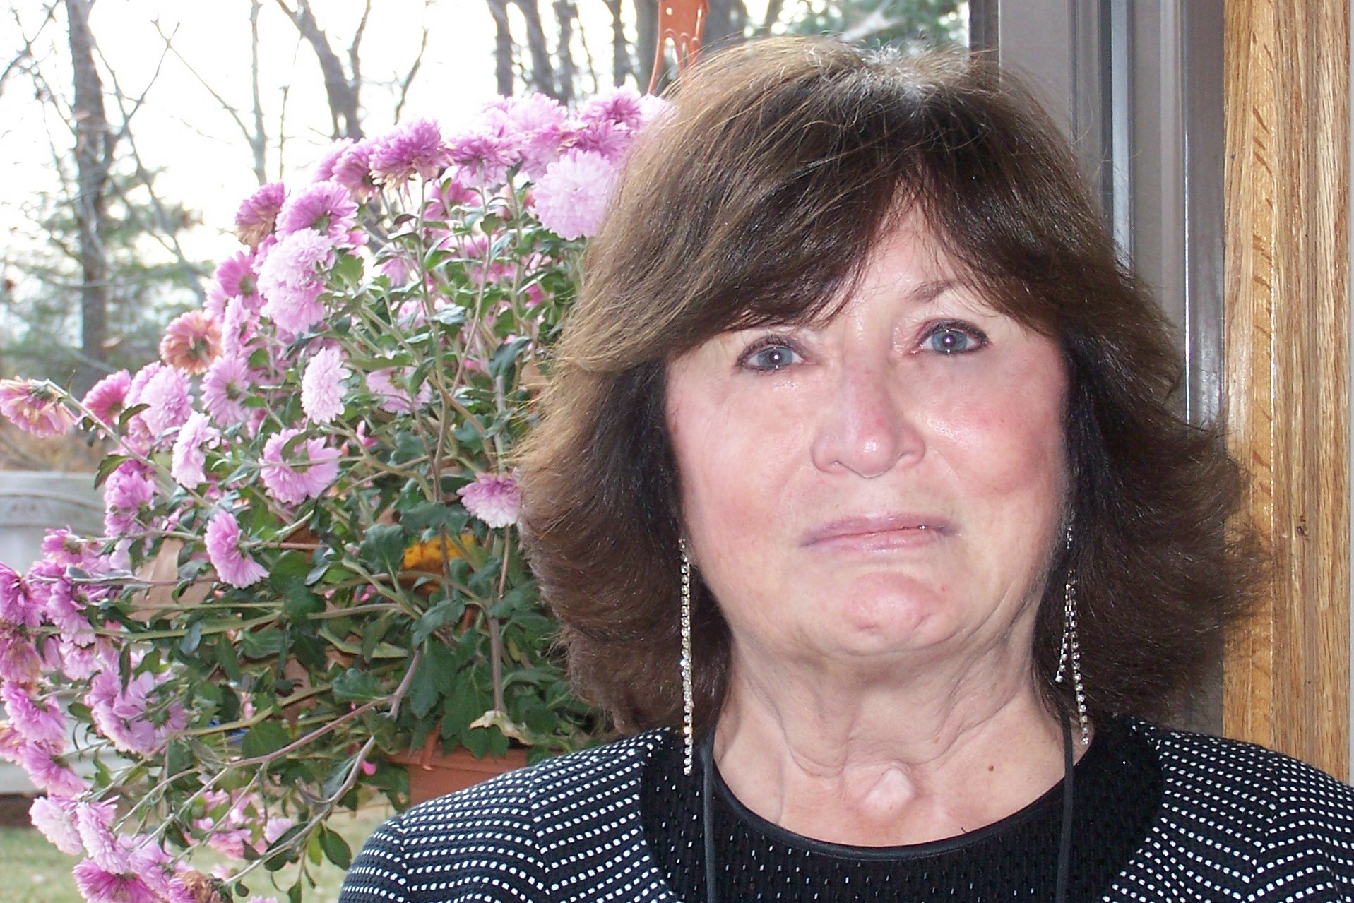

Patricia A. Barton
12 Stone Row Lane
Georgetown, MA 01833
(978) 352-5253

Background Summary
Diversified executive office experience in business and scientific environments. Strengths: detailed oriented, quick learner, management representative and liaison, decision-maker, planner and organizer, negotiator, problem-solver, intuitive aide, self-starter, challenge-oriented, well-developed communication skills (oral/written). Computer skills: MS Office, ChemDraw

Education B.A. Mount Holyoke College, 1993
Biological Sciences/English – Writing Concentration
A.A. North Shore Community College, Beverly, MA
Liberal Arts

Certificates Phi Theta Kappa, Alpha Lambda Kappa Chapter
Teacher Aide Certification/Remedial Reading
SkillPath Seminar: Dealing Effectively with Unacceptable Employee Behavior
Fred Pryor Seminar: Workshop for Effective Assistants
Fundamentals of Editing
Dun & Bradstreet Seminar: Time Management Workshop
Batten, Hudson & Swab, Inc., Executive Secretary Workshop
Family Life Institute, Group Leadership Training

Relevant Work Experience
2009 – Present Accountant, Privately-Held Publishing Co., Beverly, MA 01915 (part-time)
Comprehensive accounting in all areas of general accounting, accounts payable, accounts receivable, payroll as well as bank statements and all administrative and treasury/tax functions. Prepare and maintain financial data required by external auditing firms. Prepare financial report summaries as requested by senior management. Work closely with General Manager to develop, implement and control cash flow management operations. Manage HR/Personnel records including insurance, 401ks, hiring, terminations, benefits and labor relations.

11/94-02/2004 Executive Assistant to President, Research Contracts Specialist, Eisai Research Institute, Andover, MA 01810
Provide direct organizational support to President. Facilitate effective operation of scientific departments by the use of organizational, documentation-related and other specialized skills and by knowledge and familiarity with procedures. Demonstrate and maintain a high standard to provide a leadership role in coordinating, managing and supervising Administrative Assistants and Receptionist supporting scientific staff members. Specific responsibilities include: prioritize day-to-day work schedule; formulate and audit chemical structures; enter data and maintain ISIS compound registry, manage manuscript review process; track annual publications and presentations; process and assist in the management of outside research contracts and agreements and evaluate and negotiate issues with respect to contract interpretation using judgment in making adaptations and modifications within scope of authority; supervise the daily activities of Technical Scanner, evaluating performance and providing direction and development to ensure ongoing scheduling of scanning activities and notebook archiving, facilitate scientific meetings and minutes; coordinate, administer, review, organize, assemble and distribute various scientific reports. Develop and implement SOPs related to specific project areas.
1/94-10/94 Office Manager/Executive Assistant to the CEO/Director of Research and Development,
ARCTURUS Pharmaceutical Corporation, Woburn, MA 01801
Support CEO in all administrative duties; oversee workflow and supervise support staff; handle travel arrangements; schedule meetings; prepare corporate documents; administer stock records; maintain salary information; serve as liaison with Board of Directors and Scientific Advisory Board; purchase and procure chemicals, small lab animals, office and laboratory supplies, equipment and furniture; negotiate contracts and quotes with vendors within budgetary parameters; maintain project accounting; process invoices. Outstanding accomplishments: designed and implemented new office layout, established and maintained scientific library; background research for SBIR grants and patent applications.

Other Experience NSCC –Volunteer tutor (math/English) for adult learners/GED/ESL candidates
Advisory Board Member, BreakTime News, N. Andover, MA 01845
Board of Trustees/Executive Officer, Glen Urqhuart School, Beverly, MA 01915
Board Member/Executive Officer, Co-founder of Primary Education Unit (NDCC)

Interests Gardening, Reading, Genealogy, Writing, NS Women’s Tennis League & USTA (Captain 10 yrs)

References Available upon request

